Question 13
Develop an Embedded C Simulation for a Lubricant Monitoring Dashboard System Handling Multiple Display Updates
Aim
To develop an Embedded C simulation for a Lubricant Monitoring Dashboard that continuously monitors lubricant parameters from industrial machines and updates multiple display values in real time.

1. Problem Statement
Industrial machinery requires continuous monitoring of lubricant condition to prevent excessive wear, overheating, and equipment failure. A smart dashboard displays all lubricant-related parameters and alerts operators whenever abnormal conditions are detected.

2. System Requirements
Hardware
- Temperature Sensor
- Oil Pressure Sensor
- Oil Level Sensor
- Oil Quality (Viscosity) Sensor
- ESP32 / STM32 / ARM Cortex Microcontroller
- LCD Display
- Warning LED
- Buzzer
Software
- Embedded C
- SystemC Simulator
- Keil uVision
- Proteus

3. Functional Requirements
The dashboard should display:
- Lubricant Temperature
- Oil Pressure
- Oil Level
- Oil Quality
- Machine Running Status
- Maintenance Reminder
- Alarm Messages

4. Block Diagram

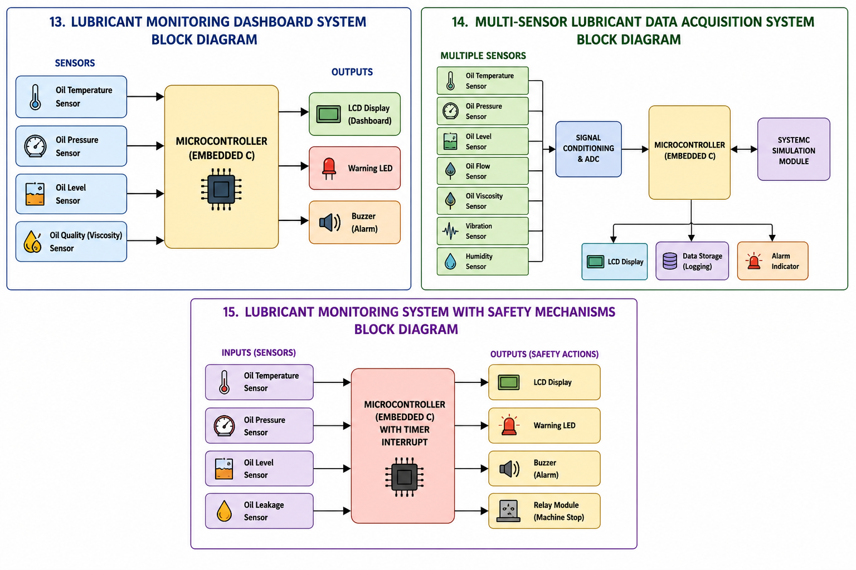

5. Working Principle
- Initialize all lubricant sensors.
- Read sensor values every second.
- Update dashboard display.
- Compare sensor values with threshold limits.
- Generate warning if:
  - Oil level is low
  - Temperature is high
  - Oil pressure decreases
  - Oil quality becomes poor
- Continue monitoring continuously.

6. Expected Output
Lubricant Dashboard

Temperature : 74°C
Pressure : 55 PSI
Oil Level : 82%
Oil Quality : GOOD

Machine Status : NORMAL
Warning Display
WARNING

LOW OIL LEVEL

Maintenance Required

7. Advantages
- Continuous lubricant monitoring
- Real-time dashboard updates
- Early fault detection
- Prevents machine breakdown
- Improves equipment life

C Code:
#include <stdio.h>
int main()
{
int temperature = 75;
int pressure = 55;
int oilLevel = 82;
int oilQuality = 90;
printf("===== LUBRICANT DASHBOARD =====\n");
while(1)
{
printf("\nTemperature : %d C\n", temperature);
printf("Pressure : %d PSI\n", pressure);
printf("Oil Level : %d %%\n", oilLevel);
printf("Oil Quality : %d %%\n", oilQuality);
if(temperature > 90)
printf("Warning : High Temperature\n");
if(pressure < 40)
printf("Warning : Low Oil Pressure\n");
if(oilLevel < 30)
printf("Warning : Low Oil Level\n");
if(oilQuality < 60)
printf("Warning : Poor Oil Quality\n");
break;
}
return 0;
}

Simulation:

